1. **Create a table**
2. 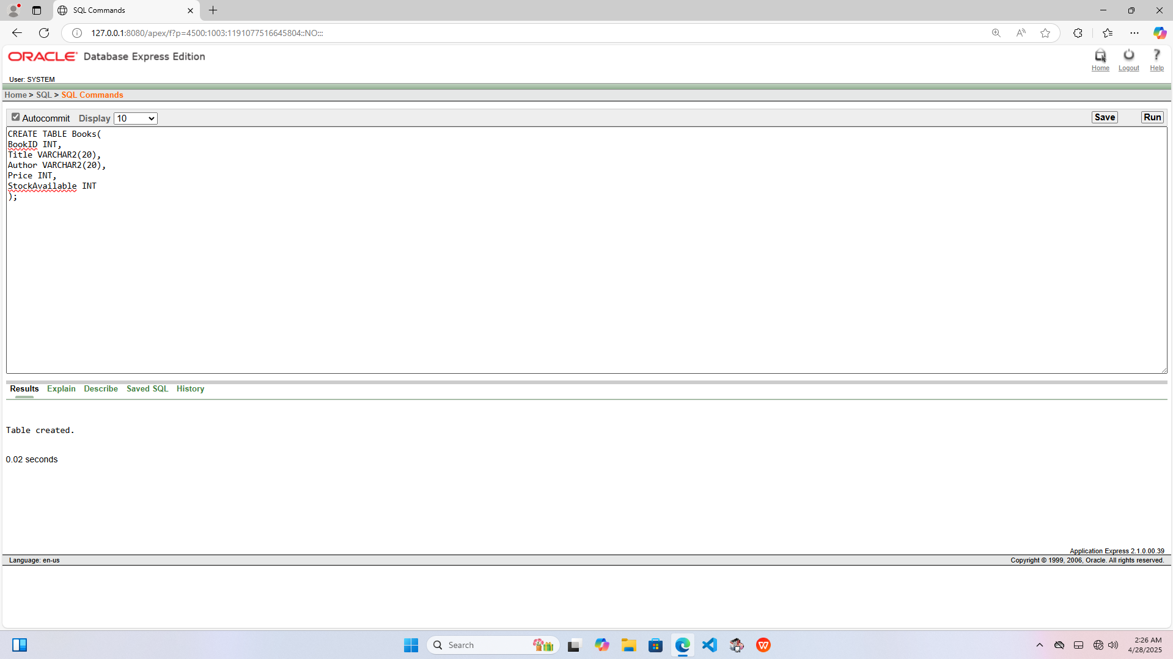

**B)Insert book records into the books table**

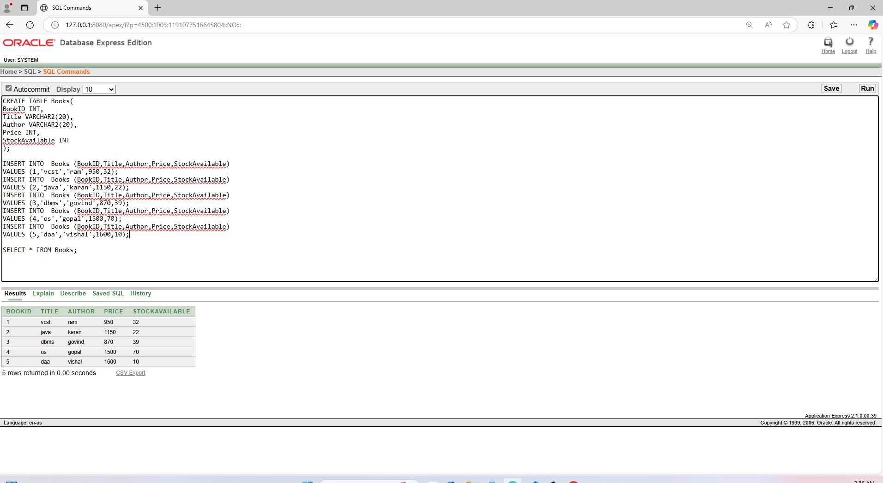

**Name :- Aditya Pandurang Takte**

**PRN NO :- 2124UMLM2074**

1. **Use the update command to increase the price of all books by rs so int the books table .**

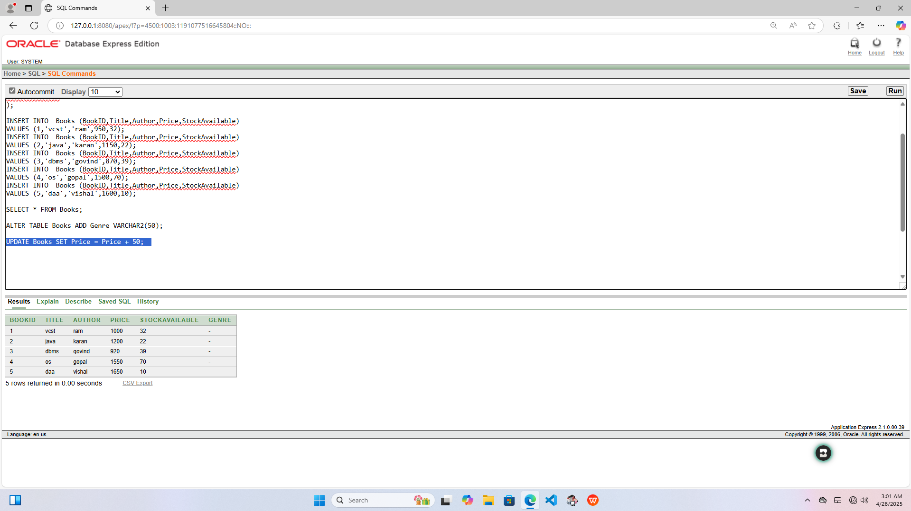

1. **Modify the structure of the books table by adding a new column gener**

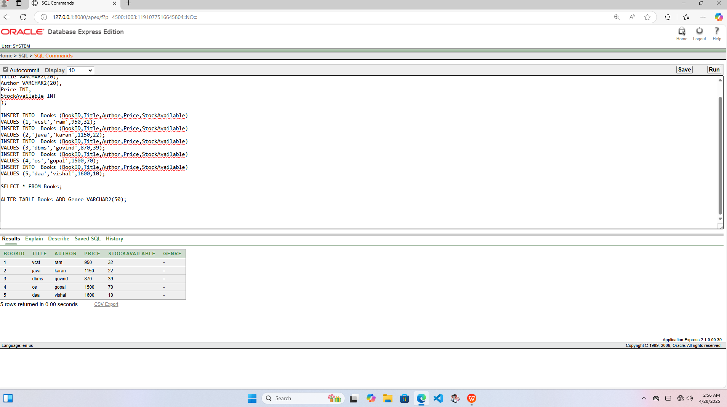

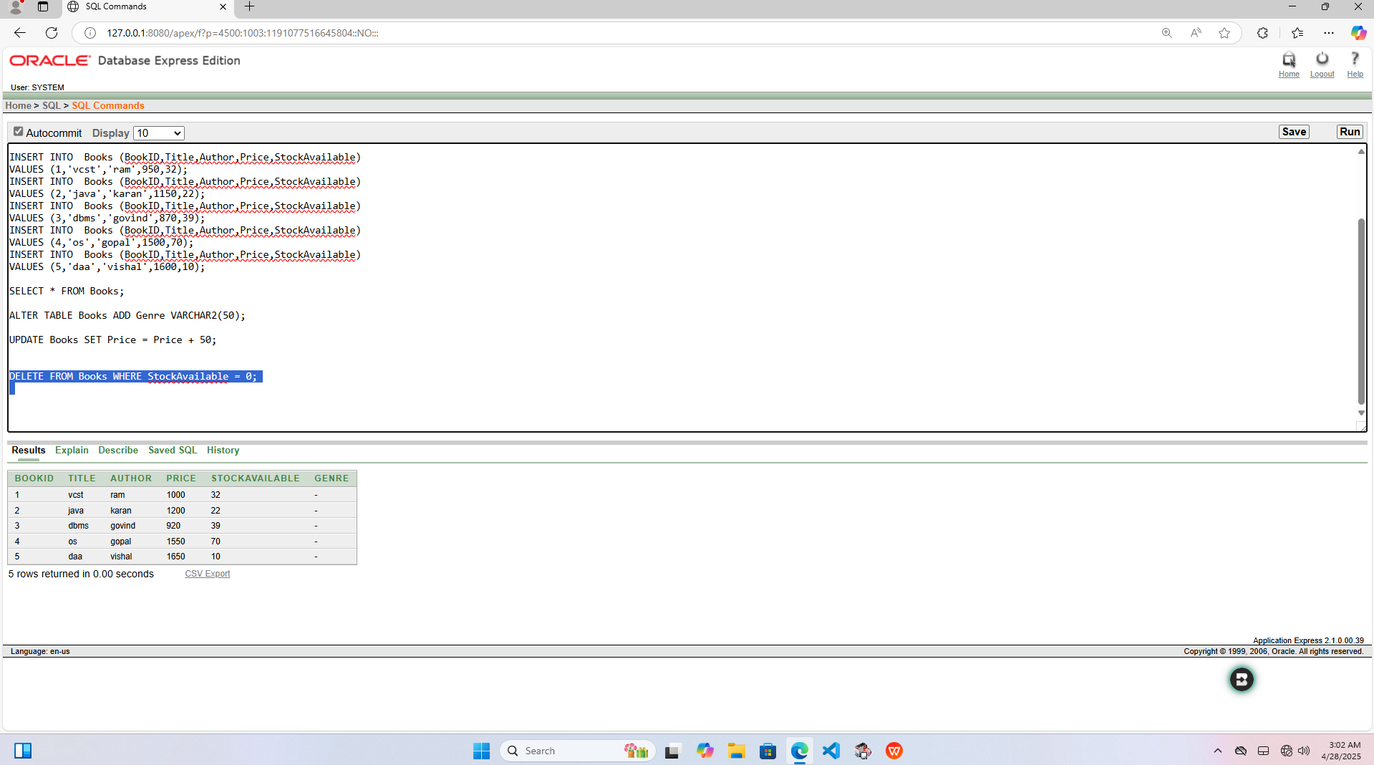

1. **Delete all records from the books where stock available is 0 using the delete command.**

